Peer-to-Peer File Sharing Systems
by
Yee H. Wong
yxw0087

1. Introduction
The objective of this project is to develop a basic Peer-to-Peer (P2P) file storage and sharing system consists of a centralized server that maintains the information about files residing on each host through file tables. Each host that connects to this centralized server is unique identified by its IP address. If a host wants a file but doesn't know the file's location, it first queries the centralized server and then sends a request to the corresponding host to download the file. Otherwise, it can communicate with the file holder directly for the file. The file sharing system supports transferring of any type of files including text files, pictures, music and video.

2. Challenges
The main challenge of this project was the use of socket programming which was fairly new to me. All that was in my knowledge was object oriented programming and it seemed to be difficult for someone who did not have any networking experience to develop the Peer-to-Peer file sharing system at start. The difficulties were overcome step by step in order to archive the final results obtained in this project. First, a simple echo server was made so that the server replies to whatever string characters the client sends to it, this is to get myself understand and familiarize with the basic concept of socket programming. When this part is done, the project was extended to building a file transfer system where the client could download a file from the server side. This part has helped me understand how to do file transferring with socket programming. After this, things become clearer to me and I extended a simple one client to one server connection to multiple clients to one server connection using the idea of parallel programming, i.e., using threads. This was done by letting the server spawning a new thread each time it accepts a connection to a client and move that connection to a new port, so that the original thread can keep listening on the same port for further connections. More details about implementation will be discussed in section 3 of this report. By doing the same thing for the client side so that each client can connect to the server while also connect to other clients, the Peer-to-Peer system is almost completed at this point. After moving the file transferring from the server side to client side, and using hash tables at the server side to maintain information of each connected host, the only thing left to do was the user interface where clients can easily choose what services it needs from the server, and with that, the whole Peer-to-Peer file sharing system has been successfully completed.

3. Implementation Details
The project was implemented through socket programming in Java, specifically, using Java.net. The server module and client module was made in two unique Java classes. On the server side, it will be listening at port 1234 for all incoming connections while the client has to connect to this port and the server's IP address. Both classes support multi-threading, in which the server can connect to multiple clients, while each client can connect to just one centralized server and multiple other clients. The connections between clients will only be done when a client requesting some file is given the information about the file holder from the centralized server. When the server accepts a connection to a client, a new thread is spawned and the connection will be moved to a new port so that the original port is open for further incoming connections. The same idea was realized in the client side for each client-to-client connection.

The server maintains a hash table that contains information about which files belong to which client. Each file is a unique key in this table, and each key being mapped to a list of clients that hold the file. When each client module is executed and connected to the server, it will first be asked to enter a directory in its local machine that holds the files it wishes to share. All files information contained in its choice of directory will be shared to the server. If the server's file table already contain a particular file, this newly joined client will be added to the list of clients, otherwise, a new entry is created in the file table for this file and the host being its only owner. Similarly, when a client leaves the server, its record will be erased from the server's file table. If a file is owned by this leaving client but has other owners, the leaving client will be removed from the list of clients associated with this file. Otherwise, if the leaving client is the only owner of the file, the file key will be removed from the file table along with its only owner's record. Other than the server-side file table, each client also has its own local file table to keep track of what files belong to which client. Initially this local table will be empty, but will be gradually filled up when the client successfully downloaded any file from other clients.

Upon using the “Update” service, a client can either add or delete file information that it wishes to be kept in the server. When “Delete” is chosen, the server can check if the file to be deleted really exists in the server and is owned by this client. If so, the file information will be removed from the file table similar to what was described when a client leaves the server, except that only the chosen file is affected, not the whole record of this client. If the file to be deleted does not exist or does not belong to this client, an error message will be printed to the client. On the other hand, to add a file to the server, the client is responsible for adding files that really exists in its directory. A client can add file information to the server without really having it, but it will not be able to fulfill a download request from other clients in the case of it being requested by other clients. This “Add” command is also automatically executed when the client has successfully downloaded a new file from another client.

With the “Request” command, a client can request for one file at each time from the server if the file information isn't already contained in its local file table. If the file information is already in its local file table, the client can directly connect to the target host and download the file. Otherwise, server will reply with a list of clients that hold the desired file. In my implementation, the client will always pick the first host from the list and connect to it for downloading. When the download is done, the requester client will automatically update its file to the server as explained above, as well as updating its local file table in case it needs to re-download the same file again when the file was lost, it can directly consult the target host. When a file holder receives the download request from the another client, it will always accept this request and first send the requester the size of the desired file, this is made so that the requester knows how large the byte array to use for. After that the file holder will send the entire byte array using outputstream's write method. When the receiver receives the file, it will be asked to enter a path to save this file. With this being said, the directory that each client enter at the beginning of execution only contains the initial files to be shared. Further files downloaded can either be put in this same directory or some other directories and the file paths will still be correctly maintained by each client for sharing. However, when asked which directory to save the downloaded file, the client must carefully enter an existing directory as well as the file name to save, otherwise the file will not be saved correctly.

One other limitation about my implementation is that each file is assumed to have an unique name globally. This means that if client 1 and client 2 both contain a file called “file01.txt” but their contents are essentially different, the server cannot distinguish the difference and will deem them to be the same file. An attempt to hash the content of file using message digest in Java was used but is eventually aborted due to the complexity given the time constraint. Further, each client is made to listen at a port number equals to the port number at which it is connected to the server minus the number “2345”. There is no special reason in choosing “2345”, it is just to guarantee that each client will be listening at a different port, and knowing that their connections to the server side will always be made at a unique port number by the program, I just subtract a constant from that port number to give the clients their own unique port numbers to listen at. Another important thing to take note is that my implementation assumes that a client can be connected to the server but not joining the file sharing system. This means that a client can use the “Request” command to download files from other clients without “joining” the file system, as well as not closing the connection to the server even after the client used the “Leave” command, which simply erases its records in the server file table.

4. Experiment Result

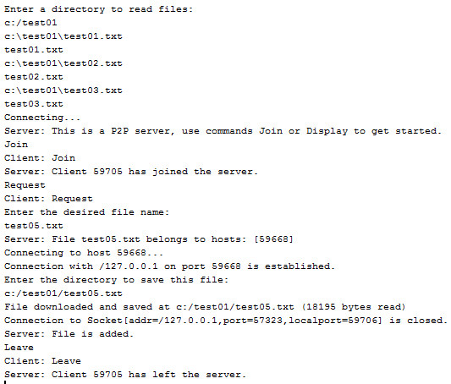
The above execution is done on the basis that the client connected to the server at port 59668 has already joined the server and contains test05.txt file. Note that the server displays the port number of the host client, but it actually also stores the IP address of the host client in the list which will guarantee uniquely identifiable clients. This sample run is done on local host machine in Windows, but it can also be done in separate machines in other platform like Linux, however, the target hostname in the client module needs to be changed to match the server's IP address for a successful connection.

5. Conclusion
This project has realized a simple implementation of Peer-to-Peer file sharing system that works not only for local host but also for real networkings. Overall, it was a very benefiting learning experience in doing this project. Future works may include fixing the limitation mentioned in section 3 as well as implementing the scoring system for which the server will only give the information of the file holder that has the best score in transferring files to the requesting client.

